OSI Layer

Task 1 :- Draw a diagram of the OSI 7-layer model and label each layer with its correct name and a real-world example of a device or protocol that operates at that layer (e.g., Switch at Data Link, HTTP at Application).

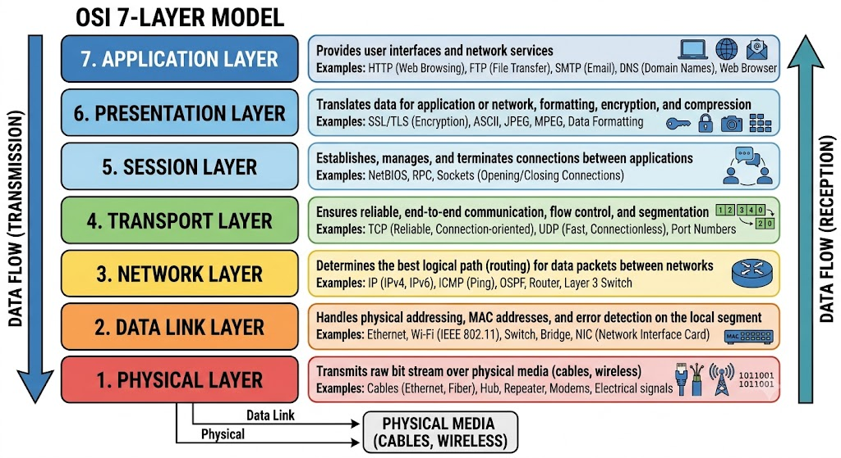
ANS :-

Layer 7: Application (HTTP, HTTPS, FTP, SMTP, DNS)
Layer 6: Presentation (SSL/TLS, ASCII, JPEG, Encryption)
Layer 5: Session (Sockets, NetBIOS, RPC)
Layer 4: Transport (TCP, UDP)
Layer 3: Network (IP, ICMP, Routers)
Layer 2: Data Link (Ethernet, Wi-Fi, Switches, MAC Addresses)
Layer 1: Physical (Cables, Fiber Optics, Hubs, Signal Bits)

Task 2 :- Match the following networking scenarios to the correct OSI layer: a) Encrypting data before sending, b) Routing packets across networks, c) Converting data to electrical signals, d) Opening a web page in your browser, e) Detecting and correcting errors in frames.

ANS :-

a) Encrypting data before sending $→$ Presentation Layer (Layer 6)
(Handles data formatting, encryption/decryption, and compression.)

b) Routing packets across networks $→$ Network Layer (Layer 3)
(Determines the optimal path and handles logical IP addressing for data packets.)

c) Converting data to electrical signals $→$ Physical Layer (Layer 1)
(Transmits raw binary bits over physical media as electrical, optical, or radio signals.)
d) Opening a web page in your browser $→$ Application Layer (Layer7)
(Provides user-facing network services using protocols like HTTP/HTTPS.)

e) Detecting and correcting errors in frames $→$ Data Link Layer (Layer2)
(Packs data into frames and handles error detection/node-to-node transfer across the local link.)

Task 3 :- Pick any app you use daily (like WhatsApp, Instagram, or Zomato) and describe how at least three different OSI layers are involved when you send or receive data in that app.

ANS :-

For Instagram :-

- Application Layer (Layer 7) :-

  - Role: The user-facing interface that initiates the request.

  - How it works: When you open Instagram and tap the "Like" button or upload a photo, the app uses HTTPS (Hypertext Transfer Protocol Secure) to format your action into an API request (e.g., POST /like) and send it to Instagram’s servers.
- 2. Presentation Layer (Layer 6) :-

  - Role: Responsible for data compression, formatting, and security.

  - How it works : Before sending your photo, Instagram compresses the image file (e.g., converting raw pixels into a compressed JPEG) to save bandwidth. It also encrypts the request using TLS/SSL encryption so your credentials and data remain secure while traveling across the internet.

3. Transport Layer (Layer 4) :-

  - Role: Manages reliable end-to-end data delivery between your phone and the server.

  - How it works: Instagram uses TCP (Transmission Control Protocol) for posts, comments, and direct messages. TCP splits your data into segments, assigns port numbers (like Port 443 for HTTPS), and ensures that every piece of your image or comment arrives completely and in the correct order without missing data.

Task 4 :- Given this scenario: You are unable to access a website, but you can successfully ping its IP address. Identify which OSI layer(s) might be causing the problem and explain your reasoning.

ANS :-

The problem is likely at Layer 7 (Application Layer) or Layer 6 (Presentation Layer).

Reason :-
- Pinging works : Ping uses ICMP at Layer 3 (Network), which proves your internet connection, cable, IP routing, and physical connection are all working fine (Layers 1, 2, and 3).

- Website won't open: The issue is higher up the stack :
  - Layer 7 (Application) :
The web server software (like Apache/Nginx) might be crashed, or the web service (HTTP/HTTPS on Port 80/443) is blocked or misconfigured.

  - Layer 6 (Presentation) :
An expired SSL/TLS security certificate on the website is blocking your browser from establishing a secure connection.

